**Agile Methodology:**

Modern approach to the software development process which prioritizes cooperation and customer, as well as fast and frequent delivery. A methodology that divides projects into smaller work units that lasts for a shorter time usually 2-4 weeks is called sprints. Agile puts much effort on flexibilities, it enables the teams to adapt to change and to integrate improvement rhythm into their workflow. They are; Planning, where software development processes and specifics are planned daily stand up: where team members meet to discuss the day’s progress; sprint review where work done is reviewed by stakeholders, and sprint retrospectives where the team reflects on what they are doing and finds ways to improve it. The most suitable cases for applying this methodology are the projects which are faced with changing requests, as this strategy provides the opportunity to implement the functional product as soon as possible.

For the project "Generative AI: In “Managing for the Short Term while Investing for the Long Term,” the Agile framework will be specific to responding to the needs and volatility of creating generative AI. By using this strategy, it will be possible to promote the cyclical growth of distinct project phases, involve all the stakeholders actively and respond to changes effectively, thus guaranteeing successful project outcomes.

**Agile Methodology for "Generative AI: Navigating Short-Term Skepticism and Long-Term Promise"**

**Key Components:**

1. **Product Backlog**:
   * **Description**: A schedule of activities and products that are most wanted in order to attain the successful end of the work. For this project, the backlog will include items such as:
     + Industry analysis of generative AI.
     + Identification and engagement with key business stakeholders.
     + Development of an Ethical AI Implementation Framework.
     + Design and testing of a generative AI chatbot.
     + Risk assessment and mitigation strategies.
     + Collaborative training and awareness programs.
2. **Sprint Planning**:In sprint planning meetings the development team will choose some of those activities from the product backlog as what to work on in the sprint. This is a process of planning which entails the assessment of overall working effort and assigning of specific targets towards a particular sprint.
3. **Example**: The players in one sprint may include carrying out industry analysis and initial interviews with the stakeholders.
4. **Sprints**:
   * **Description**: Sprint will be time boxed iterations, usually ranging from 2 to 4 weeks. Throughout each sprint, the team with assign itself to the selected tasks with the goal of coming up with a potentially shippable version of the particular project.
5. **Example**: A sprint could be creating the first version of the Ethical AI Implementation Framework and then, piloting it with the stakeholders.
6. **Daily Standup Meetings**:
   * **Description**: Brief conferences during which the individual members report their working progress, issues, and their working plan for the day.
7. **Purpose**: As a result of that to ensure an ideal setting where matters related to curriculum are addressed, there is a need to have and assure an absolute collaboration between the concerned parties to allow for a better ways of handling items of concern within the shortest time possible.
8. **Sprint Review**:
   * **Description:**Each sprint has to be concluded with a presentation of the work done to the stakeholders. It also permits an evaluation to be implemented to ensure that the project formulated corresponds to stakeholder expectations and needs.
   * **Example**: Using the feedback from the stakeholders on the functioning and the ease of the chatbot when presenting the prototype.
9. **Sprint Retrospective**:
   * **Description**: A meeting held at the end of every sprint so that individuals and teams can identify strengths, weaknesses, and opportunities for improvement, for the forthcoming sprint.
   * **Purpose**: To foster a culture of continuous improvement within the team.
10. **Increment**:
    * **Description**: The result of each sprint, which could be a functional component of the project ready for demonstration or further development.
    * **Example**: An increment might be a functioning chatbot capable of answering basic queries, ready for further refinement.

**Agile Methodology Diagram**

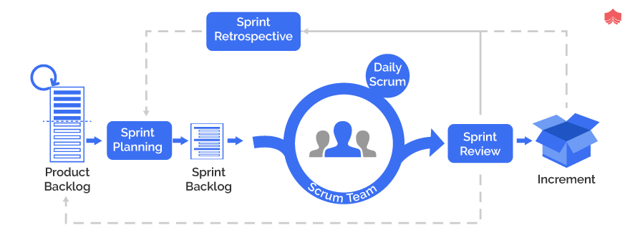

Figure 1: Agile Development Lifecycle

* **Product Backlog**: One consolidated list of the project tasks and the specifications.
* **Sprint Planning**: Gives emphasis where work is to be focused.
* **Sprint**: It means that there is a cycle of development that repeats several times with the constant participation of stakeholders.
* **Daily Standup**: Synch meetings for status reports.
* **Sprint Review & Retrospective**: Checking and possible future modifications.
* **Increment**: Any artefacts that are produced during a sprint but are ready to be reviewed or released during the subsequent sprint..

This Agile strategy allows for constant alignment with the project’s scope when it is refined, the feedback from the stakeholders involved, and the need to choose the best technical solution and still be a high-quality generative AI solution-set.